HIT140 Assessment 3 Objective 2 Regression Analysis
Avayash Gaire | ID: S400211 Bijendra Karki | ID: S397168
Ritesh Panta | ID: S397817 Kalyan Acharya | ID: S397511

Purpose and main findings
Two ordinary least squares models predict match goal difference and team goals for the 2026 FIFA World Cup using information reconstructed from earlier matches. Task 2.1 improves on a training-mean baseline on the chronological holdout; Task 2.2 does not improve squared-error performance. The findings support cautious evaluation rather than strong claims about forecast accuracy.

Data collection and cleaning
The dataset contains 104 completed matches and 208 paired team-match observations. ESPN daily scoreboard responses supply match IDs, kickoff times, teams, venues and final scores. All 104 scores were cross-checked against Mart Jürisoo’s international-results snapshot, pinned to commit b7a3a8ee5d37780c6a03101c188658fd439e241d. Targets include extra time and exclude penalty-shootout goals. Task 2.1 uses goals by team A minus goals by team B; A is the source orientation, not necessarily a home team.
Python standardises documented team aliases, checks match identity with date and orientation reconciliation, validates unique keys, numeric ranges and paired opponents, and rejects missing provenance or incorrect row counts. The reconstructed feature table has no missing values. A conflicting 1974 Tahiti and New Caledonia historical duplicate is recorded; neither team participates in this tournament, so it does not affect these predictors. Raw snapshots, URLs, source hashes and the cross-check table accompany the code.

Exactly eight predictors in each model
L10 means the last ten eligible senior internationals, across competitions. Means, rates and population standard deviations use those matches only. For Task 2.1 every quantity below is team A minus team B. For Task 2.2 “own” refers to the team whose goals form the response.
# | Task 2.1 A minus B | Task 2.2 team or opponent
1 | G Mean goals for L10 | F Own mean goals for L10
2 | A Mean goals against L10 | C Opponent mean goals against L10
3 | W Win fraction L10 | R Own days since last eligible match
4 | D Days since last eligible match | V Opponent win fraction L10
5 | M Matches in previous 365 days | S Own scoring fraction L10
6 | Q Goal difference SD L10 | K Opponent clean sheet fraction L10
7 | E Distinct World Cup editions before 2026 | T Own goals for SD L10
8 | H Host country venue advantage | B Opponent draw fraction L10

Four underlying concepts are shared: prior goals for, goals against, win fraction and days since last match. The remaining four concepts in each task differ. IDs, team names and kickoff times are metadata, not predictors. Host advantage is 1 when a host nation plays in its own country and 0 otherwise; it is then differenced for Task 2.1.

Pre match availability and leakage controls
This is a retrospective reconstruction from downloaded snapshots, not an archive proving what was published before each kickoff. A date-only historical result is eligible only after its date plus two UTC days, strictly before the target kickoff. Current-tournament labels are treated as known by kickoff plus 24 hours. Venue context is assumed known seven days in advance. These conservative bounds are explicit assumptions; delayed publication, missing history and later corrections remain possible.
No current-match shots, possession, goals or post-match statistics enter the predictors. Every nonmissing feature has provenance and an availability bound earlier than its match. Raw historical rows are filtered before rolling calculations. The current match cannot enter its own history. The interval since an earlier international is a schedule proxy, not a direct measurement of player rest.

Validation and fitting
The last 20% of distinct UTC match days are reserved as the chronological holdout. This produces 96 training matches and seven held-out matches from 10 to 19 July, equivalent to 192 and 14 team rows. One 9 July fixture remains in the full dataset but is purged from fitting because its assumed outcome-availability bound overlaps the first held-out kickoff. Whole match days and both team rows remain in the same partition.
Five expanding forward-validation periods run inside the training period after at least 20 eligible earlier matches. Training labels whose availability overlaps validation kickoff are purged. Within every fold, median imputation and standardisation are fitted using training observations only, followed by eight-predictor ordinary least squares with an intercept. Entirely missing predictors and rank-deficient designs cause a validation error. No outlier removal, feature replacement, rounding or clipping was chosen to improve holdout scores.
The baseline predicts the training target mean. Evaluation reports MAE, MSE, RMSE, R² and NRMSE, defined as RMSE divided by the training target range. Both team rows are grouped by match during validation. Task 2.2 coefficient uncertainty is clustered by match; Task 2.1 uses HC3 robust standard errors. Repeated teams and time dependence can still undermine conventional inference.

Fitted equations in original units
Using the symbols defined on page 1, the training-partition equations are:
Task 2.1
Predicted goal difference = 0.119277 + 0.681432G − 0.800474A − 0.831501W − 0.000319D + 0.018145M − 0.465088Q + 0.076973E + 0.520272H
Task 2.2
Predicted team goals = 1.962521 + 0.827363F + 0.255400C − 0.001632R − 2.029863V − 0.650848S − 0.100603K − 0.231578T − 1.268264B
The JSON artifacts retain full numerical precision and training imputation medians. A coefficient describes the change in the fitted response for a one-unit increase in that predictor, with the others held constant. For example, Task 2.1 estimates 0.681 additional goal difference per unit of prior scoring-mean difference. Correlated predictors can produce counterintuitive conditional signs; these coefficients do not establish causal effects.

Reproducibility
The named member scripts share project.py and build_dataset.py. A pinned requirements file, data and provenance CSVs, original source snapshots, model JSON files, equations, partition manifests and automated checks accompany the analysis. START_HERE.bat creates an environment and runs the integration; the offline results page shows the outputs. No artificial test fixtures are used as tournament observations.

Predictive performance
Task and model | MAE | MSE | RMSE | NRMSE | R²
2.1 OLS | 1.2112 | 1.9662 | 1.4022 | 0.1402 | 0.1079
2.1 Mean baseline | 1.5030 | 2.8546 | 1.6896 | 0.1690 | −0.2951
2.2 OLS | 1.1269 | 2.7082 | 1.6456 | 0.2351 | −0.1246
2.2 Mean baseline | 1.1429 | 2.5672 | 1.6023 | 0.2289 | −0.0660

Task 2.1 reduces holdout MAE and RMSE relative to its baseline but explains little holdout variation. Task 2.2 marginally reduces MAE while increasing RMSE. Its negative R² means it is worse than predicting the holdout response mean; its RMSE also exceeds the implementable training-mean baseline. So on this test period the goals model is not a better squared-error predictor than the baseline.
Within the training period, pooled out-of-fold RMSE is 1.6921 for Task 2.1 versus 2.0671 for its baseline, and 1.2268 for Task 2.2 versus 1.3155. OLS RMSE varies from 1.0123 to 2.1301 and 1.0216 to 1.3663 across the five folds. Better earlier validation does not guarantee performance in the small later-stage holdout. Detailed row-level predictions and fold metrics are retained rather than replaced by training fit statistics.
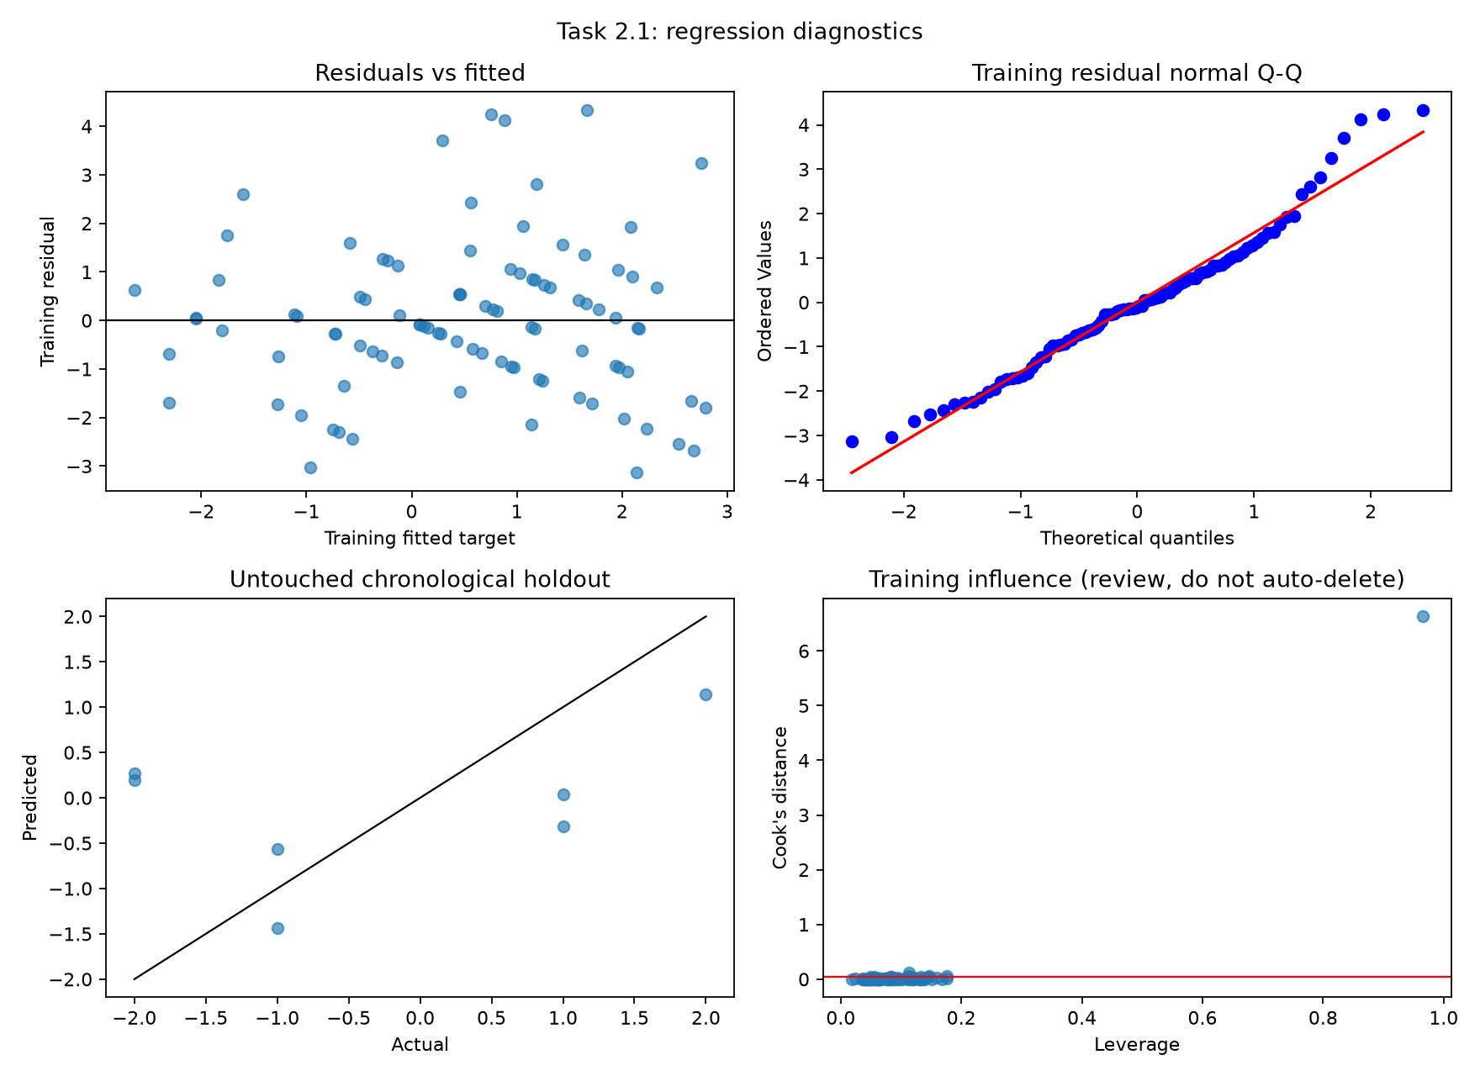
Figure 1 Task 2.1 diagnostics. Fitted residuals, normal Q-Q plot and influence use training data; the actual-versus-predicted panel uses the chronological holdout.

Goal difference diagnostics
Training R² is approximately 0.416 and adjusted R² is 0.363; these are not test accuracy. Maximum VIF is about 3.98. The Saudi Arabia v Uruguay training fixture has leverage about 0.966 and Cook’s distance about 6.63. Historical coverage yields a 76-day Uruguay interval, producing an extreme schedule difference. A training-only sensitivity refit excluding this flagged fixture changes the interval coefficient from approximately −0.000319 to 0.178723. This instability weakens interpretation of that coefficient. The main model retains the fixture and all eight predictors; the sensitivity comparison does not replace it.

Goals scored diagnostics
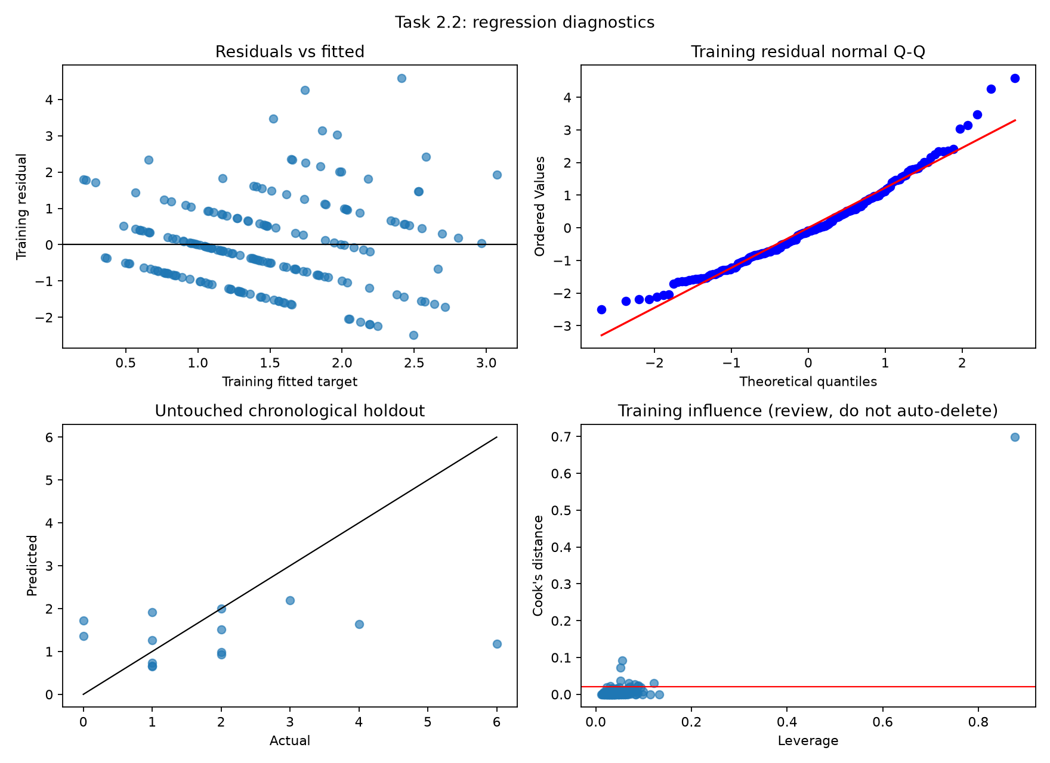
Figure 2 Task 2.2 diagnostics. Two rows per match are kept together during evaluation; inference is clustered by match.
Training R² is approximately 0.199 and adjusted R² is 0.164. The Breusch-Pagan p-value is about 0.020, consistent with nonconstant residual variance. Maximum VIF is about 6.49 for prior mean goals scored, indicating correlated form measures and uncertain individual effects. Q-Q upper-tail departures and the discrete, nonnegative goals target limit a Gaussian linear description. OLS outputs remain continuous; no rounding or truncation was used for evaluation. There are no negative Task 2.2 holdout predictions.

Limitations and conclusion
Seven held-out matches provide a fragile basis for generalisation. Later knockout matches differ from group-stage games, and the two team outcomes are dependent. Historical coverage, national-team naming, match-date reconciliation and retrospective corrections can affect reconstructed predictors. The extra-time convention must be aligned with the assessment interpretation. Row counts and timing checks passing does not remove these limits.
The goal-difference model outperforms the baseline on this holdout, whereas the goals-scored model does not on RMSE. Both tasks use the specified dataset and predictor structure, and the validation evidence is saved with the code. Further improvement would require independently verified pre-match information and validation confined to training periods; repeatedly tuning to the same holdout would only produce a better-looking score.

Member roles and repository
Roles: Avayash Gaire, source reconstruction and data validation; Bijendra Karki, Task 2.1 model and diagnostics; Ritesh Panta, Task 2.2 model and diagnostics; Kalyan Acharya, integration and reproducibility. Repository with the Python code and datasets: https://github.com/bijendrakarkiS397168/HIT140-Assessment3-Group-Project/tree/main

